PROJECT REPORT
AI-Augmented AI BlogNest
Design, Implementation and Testing of an AI-Powered Blog Management REST API
Node.js | Express.js | MongoDB | Mongoose | JWT | Google Gemini

Item | Details
Project title | AI-Augmented AI BlogNest (backend REST API)
Document type | Project report and technical documentation
Reference material | AI_BlogNest_API demo document and API demo screen recording
Base URL (local) | http://localhost:5000
Report date | September 29, 2026
Version | 1.0

Contents
1. Abstract
2. Introduction
3. Scenario-Based Case Study
4. Existing System vs. Proposed System
5. Requirement Analysis
6. System Architecture
7. Database Design
8. Project Setup and Structure
9. Backend Implementation
10. AI Integration Layer
11. API Specification
12. Security Design
13. Testing and Verification
14. Results and Performance Analysis
15. Deployment Guide
16. Limitations and Future Enhancements
17. Conclusion
References
Appendix A: Resource Links
Appendix B: Environment Variables
Appendix C: Glossary

1. Abstract
Content creators spend a large share of their time on tasks that surround writing rather than writing itself: organizing drafts, tagging and categorizing posts, moderating feedback, and repeatedly producing first drafts and summaries. AI BlogNest is a backend REST API that addresses this problem by combining a conventional blog-management service with generative AI.
The system is built with Node.js and Express.js and stores its data in MongoDB through the Mongoose object-document mapper. Users register and sign in with an email and password; passwords are stored as hashes and sessions are represented by stateless JSON Web Tokens (JWT). Authenticated users can create and fetch blog posts. Two AI endpoints are integrated with Google Gemini through the official @google/generative-ai SDK: POST /api/ai/generate-blog writes a complete post from a topic and category and saves it under the caller's account, and POST /api/ai/summarize condenses any supplied text into a short abstract.
The codebase follows the Model-View-Controller pattern with a dedicated services layer for external AI calls. This report documents the problem being solved, the requirements, the architecture, the database design, the implementation, the API contract, the security controls and the verification carried out in the demonstration. In that demonstration, registration, login, blog creation, blog retrieval, AI blog generation and AI summarization were all exercised through an API client against a live MongoDB Atlas cluster. Transactional endpoints responded in under 150 ms, while the AI endpoints responded in roughly four to six seconds, which is dominated by model latency.
Keywords: REST API, Node.js, Express.js, MongoDB, Mongoose, JWT authentication, generative AI, Google Gemini, blog CMS, content summarization.

2. Introduction

2.1 Background
Blogging remains one of the most effective ways for individuals and organizations to build an audience, but producing a steady stream of quality posts is demanding. A working content creator must research a topic, draft, revise, categorize, publish, and then read the audience response. Traditional content management systems handle storage and publishing well, yet they offer little help with the creative and editorial work itself.
Large language models change this equation. A model can turn a short topic into a coherent first draft in seconds and can compress a long article into a few sentences suitable for a preview card or a newsletter blurb. To use those capabilities safely inside a product, the model must sit behind a secured, well-structured backend that controls who may call it, stores the results, and shields the client application from vendor-specific details. AI BlogNest is that backend.

2.2 Problem Statement
Creators who manage several blogs face the following recurring difficulties:
- Drafts, categories and tags are spread across tools and are hard to keep consistent.
- There is no single, secured interface through which a web or mobile front end can create and read posts.
- First drafts and summaries are written by hand, which is slow and repetitive.
- AI services are typically called directly from client applications, which exposes API keys and makes usage impossible to control.
- Access is all-or-nothing: there is no separation between people who may read, write or administer content.

2.3 Objectives
- Provide a secure user registration and login service using hashed passwords and JWT tokens.
- Provide RESTful endpoints to create and retrieve blog posts, each linked to the authoring user.
- Integrate a generative AI model to write full blog posts from a topic and category.
- Integrate the same model to summarize arbitrary text into a concise abstract.
- Keep all secrets (database URI, JWT secret, AI key) out of source code by using environment variables.
- Structure the code with MVC and a services layer so that features can be added without rewriting existing modules.
- Verify every endpoint with an API client and record the observed status codes and response times.

2.4 Scope
The project delivers a headless backend. There is no browser user interface; the API is consumed through Postman or Thunder Client during development and is designed so that a React, Angular or mobile front end can be attached later. The implemented scope covers authentication, blog creation and retrieval, and the two AI features. Capabilities described in the design documents but not yet implemented (role tiers such as Editor and Admin, comment moderation, scheduling, likes and a separate category collection) are treated in Section 16 as planned extensions so that the report stays truthful about what was demonstrated.

2.5 Report Organization
Sections 3 to 5 describe the need and the requirements. Sections 6 to 8 explain the architecture, database and project layout. Sections 9 to 12 describe how the system was built, including the AI layer, the API contract and the security design. Sections 13 and 14 present the tests and measured results. Sections 15 to 17 cover deployment, limitations and conclusions.

3. Scenario-Based Case Study

3.1 Background
Priya is a content creator who manages several blogs on technology, travel and productivity. She publishes every week for each blog and works with a part-time editor. Her workflow is spread across notes apps, spreadsheets and a basic publishing tool.

3.2 Problem
- Multiple drafts, categories and tags are difficult to keep organized.
- She has little visibility into which posts perform well.
- Approving content and moderating comments takes time she would rather spend writing.
- Uploading media and tracking its metadata is manual.
- There is no clean way to give her editor and guest authors different levels of access.

3.3 Solution
AI BlogNest gives Priya a central, secured API that separates business logic from any front end. Her writing tools authenticate once, receive a token, and use it to create and read posts. When she needs a first draft on a new subject, one call to the AI endpoint returns a complete article that is already stored under her account. When she wants a teaser for a newsletter, she sends the full article to the summarize endpoint and receives a short abstract.

3.4 Usage
Actor | How the actor uses the system
Author (implemented) | Registers, logs in, creates posts manually, asks the AI to generate a post from a topic, and summarizes long content.
Reader (implemented) | Retrieves the list of blog posts, each with the author's name and email.
Editor (planned) | Reviews drafts, changes publication status and cleans up categories.
Admin (planned) | Manages users and roles, removes abusive content, and inspects logs.

3.5 Outcome
Moving workflow control into a backend service reduces delays between an idea and a published draft. Schema validation keeps data consistent, the authentication layer ensures only signed-in users can write, and the AI endpoints turn hours of drafting into seconds. Because every generated post is stored with an author reference and timestamps, the same data can later feed analytics such as posts per author, posts per category and growth over time.

4. Existing System vs. Proposed System

4.1 Existing Approach
Small creators typically combine a hosted blogging platform with separate AI chat tools. Text is generated in one place, copied by hand into another, formatted, categorized and published. Each hand-off is a chance for errors, and none of the tools share a common identity or data model. Teams that do build their own service often call an AI vendor straight from the browser, which leaks keys and offers no control over cost or abuse.

4.2 Proposed System
AI BlogNest introduces a single API that owns identity, data and AI access. The client never sees the AI key. Every AI request passes through authentication, is validated, is forwarded by a dedicated service module and, where appropriate, is persisted as a normal blog document.

4.3 Comparison
Aspect | Manual / fragmented approach | AI BlogNest
Draft creation | Written by hand or copied from a chat tool | One call to /api/ai/generate-blog returns and stores the draft
Summaries | Written manually | One call to /api/ai/summarize
Identity | Separate accounts per tool | Single account with JWT bearer tokens
AI key handling | Often exposed in client code | Held only on the server in environment variables
Data consistency | Depends on the tool | Mongoose schemas enforce required fields
Extensibility | Limited by each vendor | New routes, controllers and services can be added independently
Traceability | None | Each post stores author reference and timestamps

5. Requirement Analysis

5.1 Functional Requirements
ID | Requirement | Status
FR-01 | A visitor can register with name, email and password; duplicate emails are rejected. | Implemented
FR-02 | A registered user can log in and receive a JWT. | Implemented
FR-03 | An authenticated user can create a blog post with title, content and category. | Implemented
FR-04 | Any client can retrieve the list of blog posts including author details. | Implemented
FR-05 | An authenticated user can request an AI-generated post from a topic and category; the post is saved. | Implemented
FR-06 | A user can submit text and receive an AI-generated summary. | Implemented
FR-07 | The API reports errors as JSON with an appropriate HTTP status code. | Implemented
FR-08 | Role tiers (Reader, Author, Editor, Admin) restrict privileged operations. | Planned
FR-09 | Editors can approve or schedule posts; comments can be moderated. | Planned
FR-10 | Users can update and delete their own posts. | Planned

5.2 Non-Functional Requirements
Category | Requirement
Security | Passwords hashed; stateless token authentication; secrets kept in environment variables; secrets excluded from version control through .gitignore.
Performance | Database-backed endpoints should answer in well under one second; AI endpoints are bounded by model latency.
Reliability | Startup must fail fast when MONGO_URI is missing or the database cannot be reached.
Maintainability | MVC separation, one file per concern, and a services layer for external calls.
Portability | Runs unchanged on Windows, macOS and Linux with Node.js.
Usability | Consistent JSON request and response bodies that are easy to test in Postman or Thunder Client.

5.3 Software Requirements
Component | Version / Detail | Purpose
Operating system | Windows 10/11, macOS or Linux | Development and hosting
Node.js | v16 or above | JavaScript runtime for server logic
npm | v8 or above | Dependency management
Express.js | Web framework | Routing, middleware, JSON parsing
MongoDB / Atlas | NoSQL document database | Stores users and blog posts
Mongoose | ODM library | Schemas, validation, queries
Google Generative AI SDK | @google/generative-ai | Access to Gemini models
Postman / Thunder Client | API client | Manual endpoint testing
Visual Studio Code | Code editor | Development environment

5.4 Hardware Requirements
Resource | Minimum | Recommended
Processor | Intel Core i5 (8th gen) / AMD Ryzen 5 | Same or better
Memory | 8 GB | 16 GB when running several services together
Storage | 1 GB free | 2 GB free including node_modules and logs
Network | Internet access for MongoDB Atlas and Gemini | Stable broadband

6. System Architecture

6.1 Layered Overview
The backend is organized as a pipeline. A request from an API client reaches the Express server, passes through middleware (CORS, JSON parsing, request logging and, for protected routes, authentication), is dispatched by a route to a controller, and is finally resolved against the Mongoose models or the AI service. The response travels back along the same path, and any thrown error is caught by a central error handler.
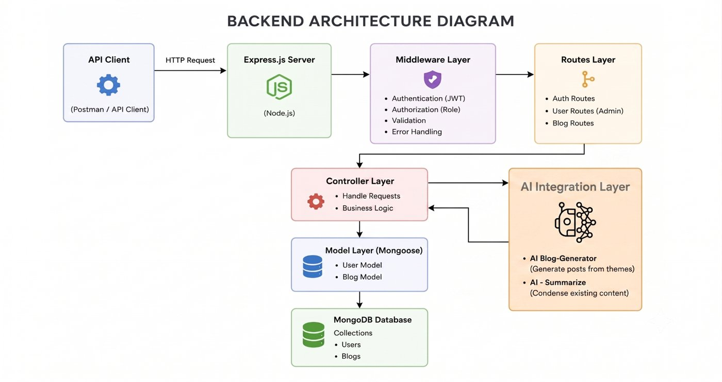
Figure 6.1: Backend architecture diagram (from the demo document)

6.2 Component Responsibilities
Component | Responsibility
API client | Postman or Thunder Client during development; a web or mobile front end in production.
Express server (app.js, server.js) | Loads environment variables, connects to MongoDB, mounts routes, and listens on the configured port.
Middleware layer | CORS, JSON body parsing, morgan request logging, JWT verification and error handling.
Routes layer | authRoutes, blogRoutes and aiRoutes map URL paths and HTTP methods to controllers.
Controller layer | Validates input, applies business rules and shapes JSON responses.
Services layer | geminiService encapsulates all communication with the Gemini model.
Model layer | User and Blog Mongoose schemas define structure and validation.
MongoDB | Persistent storage in the Users and Blogs collections.

6.3 User Flow
Every interaction begins with an API request. The client authenticates with email and password, the server issues a signed JWT, and the client attaches that token to later requests. After verification the request continues to standard blog operations or to the AI services, and the result is stored in or read from MongoDB.
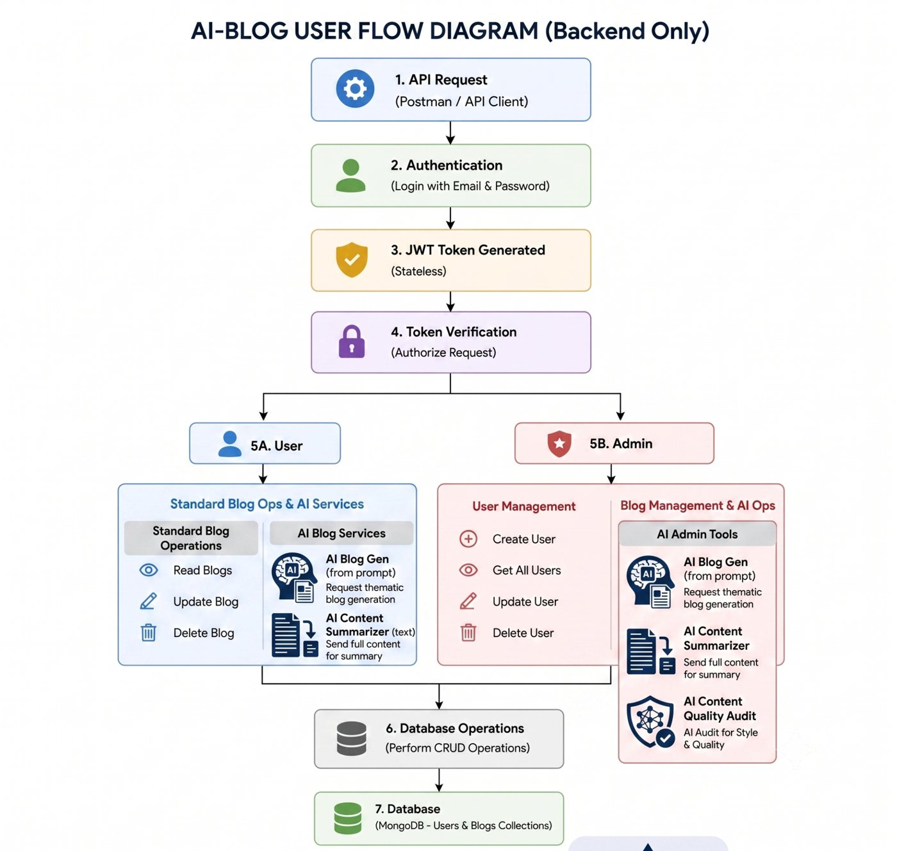
Figure 6.2: Backend user flow diagram (from the demo document)

6.4 MVC Pattern
The project applies Model-View-Controller to keep responsibilities separate. Because the service is headless, the "view" is the routing layer rather than an HTML template.
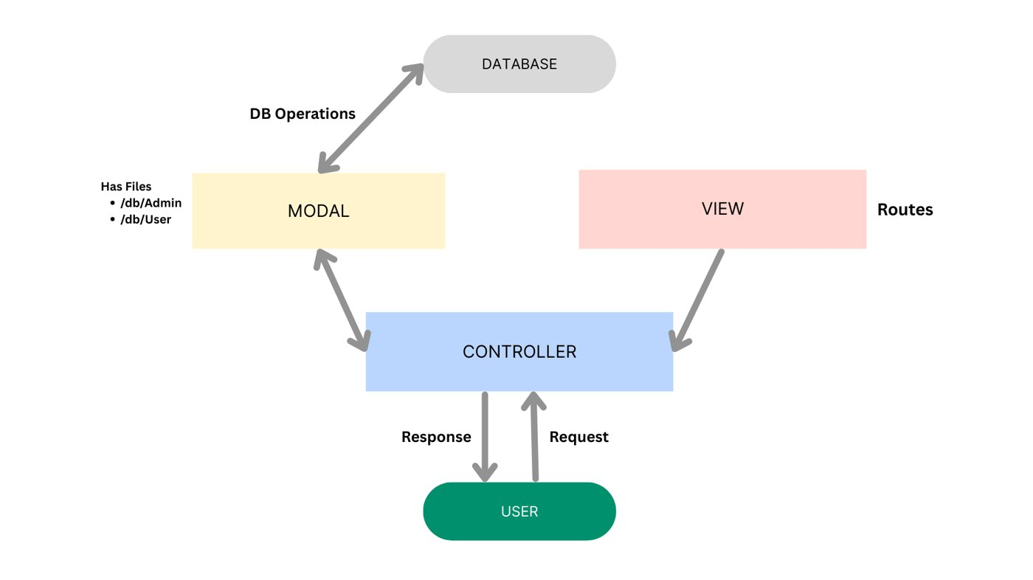
Figure 6.3: MVC interaction between user, controller, model and routes
Layer | Role in AI BlogNest | Files
Model | Mongoose schemas with validation, defaults and timestamps. | src/models
Controller | Reads the request, calls models or services, and returns JSON. | src/controllers
View (routing) | Binds paths such as /api/blogs to controller functions. | src/routes
Service | Isolates the Gemini SDK from the rest of the code. | src/services

6.5 Request Lifecycle Example
The following steps trace a call to POST /api/ai/generate-blog:
- The client sends a JSON body containing a topic and category with an Authorization: Bearer <token> header.
- Express parses the JSON body and morgan logs the request.
- The authentication middleware verifies the token and attaches the user to the request.
- The AI controller validates that a topic exists.
- The Gemini service builds a prompt and calls the model.
- The controller stores the generated text as a Blog document with the caller as author.
- The API responds with HTTP 201 and the saved document. If the model fails, the error handler returns a JSON error instead.

7. Database Design

7.1 Design Approach
MongoDB is used because blog posts are naturally document-shaped: a title, a body of text, a category and a reference to an author. Flexible schemas make it simple to add fields such as tags, cover images or status later, and Mongoose adds the validation that a document database lacks by default.

7.2 Entity-Relationship Diagram
The ER diagram below shows the target data model of the platform. The implemented API currently persists the User and Blog entities; the Category, Comment and Like relationships are part of the roadmap.
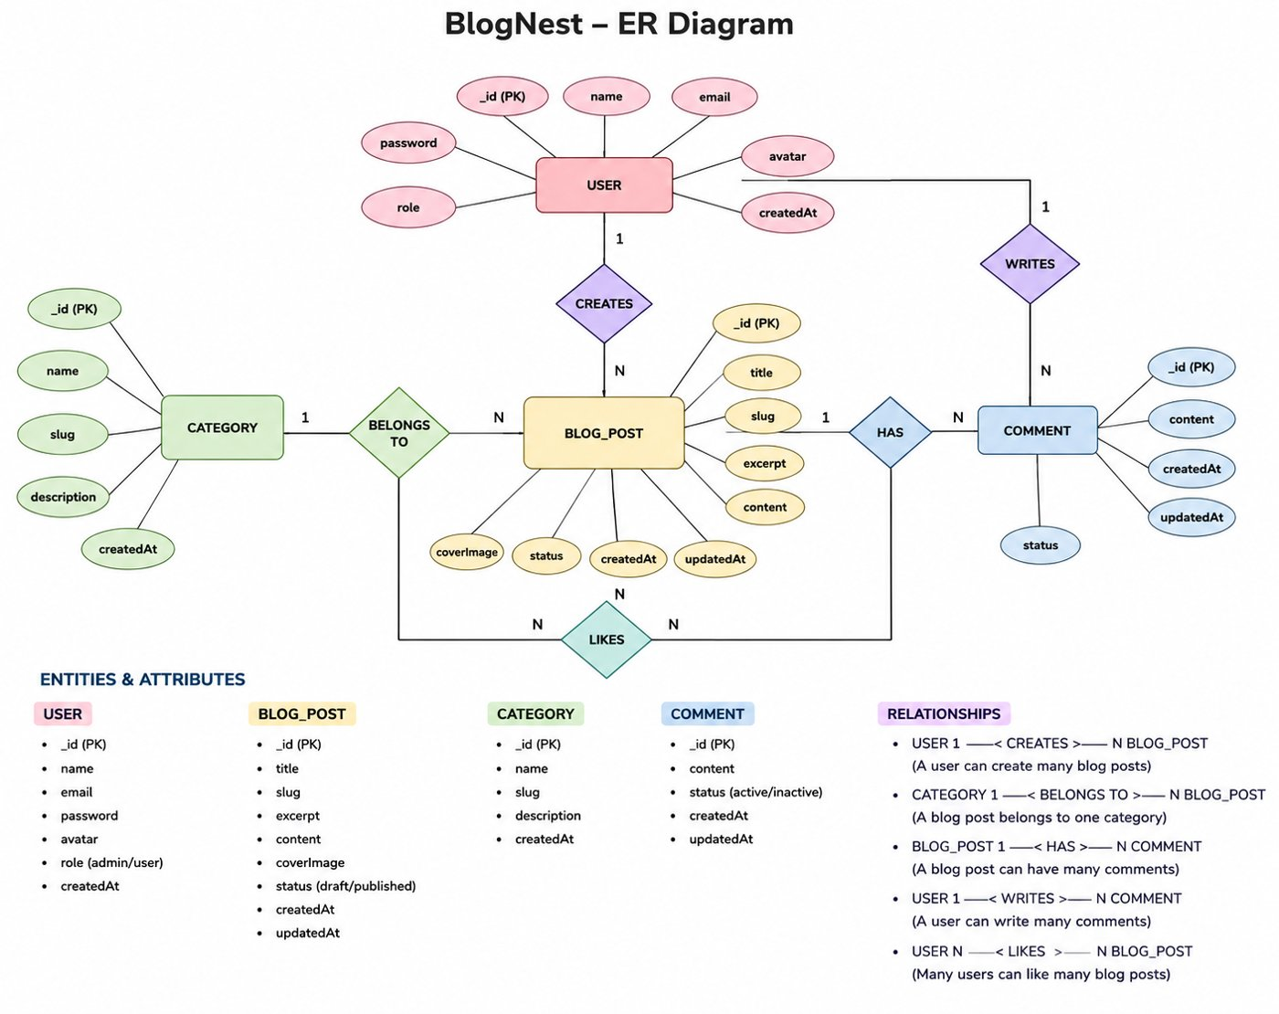
Figure 7.1: BlogNest ER diagram (from the demo document)

7.3 Implemented Collections

Users collection
Field | Type | Constraints
_id | ObjectId | Primary key generated by MongoDB
name | String | Required, trimmed
email | String | Required, unique, lowercase, trimmed
password | String | Required, minimum length 6, stored as a hash
createdAt / updatedAt | Date | Added automatically by timestamps: true

Blogs collection
Field | Type | Constraints
_id | ObjectId | Primary key
title | String | Required
content | String | Required; body of the article
category | String | Topic label such as "Technology"
author | ObjectId (ref User) | Links the post to its creator; populated on fetch
authorName | String | Denormalized copy of the author's name for fast display
createdAt / updatedAt | Date | Added automatically
__v | Number | Mongoose version key

7.4 Relationships
- User to Blog (one-to-many): one user can author many posts; each post references exactly one author.
- Planned: Category to Blog (one-to-many), Blog to Comment (one-to-many), User to Comment (one-to-many) and a many-to-many Likes relation.

7.5 Design Decisions
- Referencing plus denormalization. The post stores the author's ObjectId for integrity and the author's name for quick rendering. The fetch endpoint additionally populates author name and email.
- Unique email index. Duplicate registrations are blocked at both the application and database level.
- Timestamps. Enabled on both schemas so that ordering and later analytics do not need extra fields.

8. Project Setup and Structure

8.1 Creating the Project
- Create a folder named AI-BLOG NEST and open it in Visual Studio Code.
- Open the integrated terminal and run npm init -y to create package.json.
- Install runtime dependencies: npm install express mongoose dotenv cors morgan bcryptjs jsonwebtoken @google/generative-ai.
- Install the development dependency: npm install --save-dev nodemon.
- Create the src folder with the sub-folders described below, plus app.js and server.js.
- Create a .env file for secrets and a .gitignore that lists node_modules and .env.

8.2 Folder Structure
The layout below is taken directly from the project explorer in the demo. Each folder holds one kind of file so that a developer can locate any feature quickly.
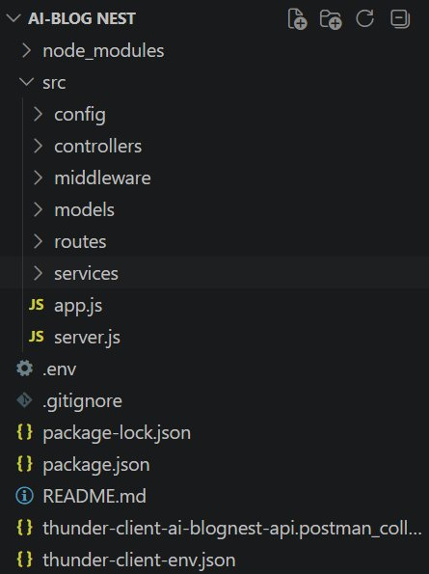
Figure 8.1: Project explorer showing the src folder layout
Path | Contents
src/config | db.js: MongoDB connection routine.
src/controllers | authController, blogController, aiController.
src/middleware | authMiddleware (JWT verification) and errorMiddleware.
src/models | User and Blog schemas.
src/routes | authRoutes, blogRoutes, aiRoutes.
src/services | geminiService.js: wrapper around the Gemini SDK.
src/app.js | Express application: middleware and route mounting.
src/server.js | Entry point: environment, database and port.
.env / .gitignore | Secrets and ignore rules.
README.md, thunder-client-*.json | Documentation and exported API test collection.

8.3 npm Scripts
Command | Effect
npm start | Runs the server once with Node.
npm run dev | Runs the server with nodemon, restarting on changes to .js, .json and .env files (used in the demo recording).

8.4 Environment Configuration
The application reads its configuration from a .env file. A template is shown below; the real values must never be committed to version control.
PORT=5000
MONGO_URI=mongodb+srv://<user>:<password>@<cluster>.mongodb.net/blognest
JWT_SECRET=<long-random-string>
GEMINI_API_KEY=<your-google-ai-studio-key>
GEMINI_MODEL=<gemini-model-name>
NODE_ENV=development
Listing 8.1: .env template

9. Backend Implementation

9.1 Express Application (app.js)
app.js builds the Express application without starting it, which makes the app importable by test tools. It enables CORS, JSON body parsing and morgan request logging, mounts the three route groups under /api/auth, /api/blogs and /api/ai, registers the error middleware after the routes, and exposes a health-check route at /.
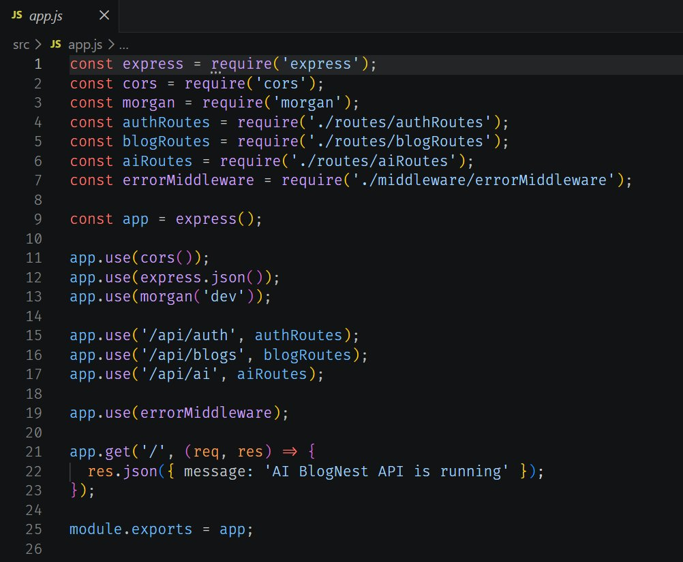
Figure 9.1: src/app.js

9.2 Server Entry Point (server.js)
server.js loads environment variables, opens the database connection and starts listening. The port comes from PORT and falls back to 5000. On success the console prints the port number, which is the line seen in the terminal during the demo.
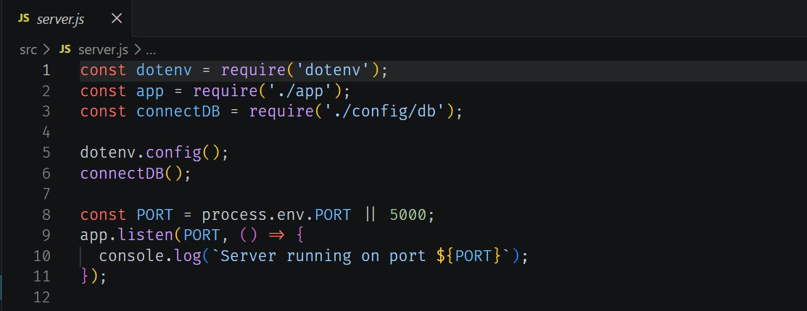
Figure 9.2: src/server.js

9.3 Database Connection (config/db.js)
The connection routine reads MONGO_URI and stops the process immediately if it is missing. It then calls mongoose.connect and logs the host name on success. Any connection failure is logged and terminates the process, so the service never runs in a half-working state. The demo terminal shows the message "MongoDB connected" followed by an Atlas shard host.
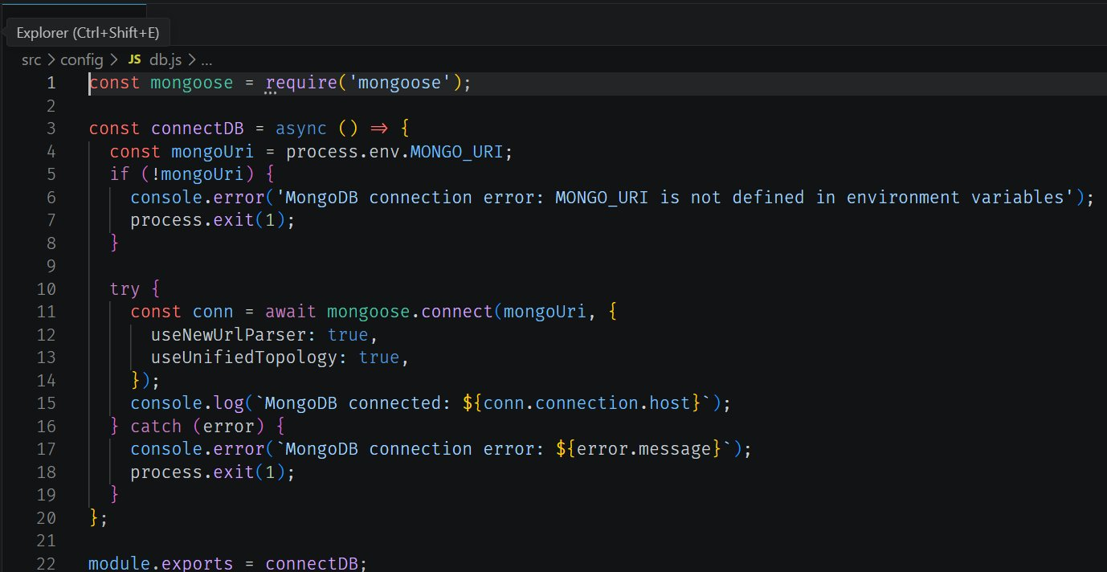
Figure 9.3: src/config/db.js

9.4 User Model
The User schema requires a name, requires a unique lowercase email and requires a password of at least six characters. Enabling timestamps adds createdAt and updatedAt automatically.
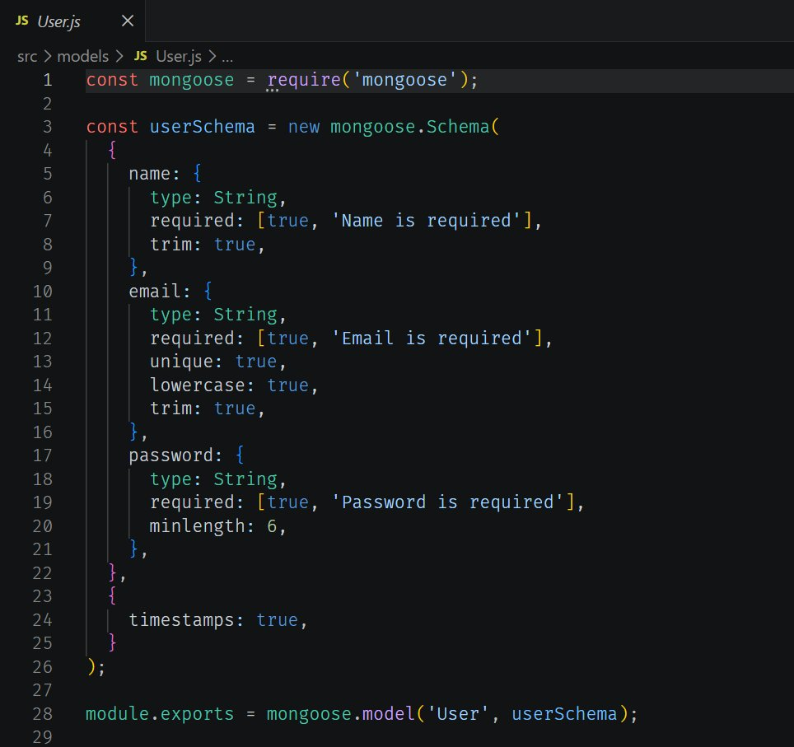
Figure 9.4: src/models/User.js

9.5 Blog Model
The Blog model is consistent with the documents returned in the demo responses: title, content, category, an author reference and a copy of the author's name. The listing is a representative implementation of that structure.
const mongoose = require('mongoose');

const blogSchema = new mongoose.Schema(
{
title: { type: String, required: true, trim: true },
content: { type: String, required: true },
category: { type: String, default: 'General', trim: true },
author: { type: mongoose.Schema.Types.ObjectId, ref: 'User',
required: true },
authorName: { type: String },
},
{ timestamps: true }
);

module.exports = mongoose.model('Blog', blogSchema);
Listing 9.1: src/models/Blog.js (representative)

9.6 Authentication Controller
Registration checks whether the email already exists, hashes the password with bcrypt and returns 201 with the new user's id, name and email. In the terminal recording a second registration attempt with the same data produced a 400 response, which confirms duplicate detection. Login compares the submitted password with the stored hash and returns a signed token. The listing is a representative implementation matching the observed responses.
const bcrypt = require('bcryptjs');
const jwt = require('jsonwebtoken');
const User = require('../models/User');

exports.register = async (req, res, next) => {
try {
const { name, email, password } = req.body;
if (await User.findOne({ email })) {
res.status(400);
throw new Error('User already exists');
}
const hashed = await bcrypt.hash(password, 10);
const user = await User.create({ name, email, password: hashed });
res.status(201).json({
message: 'User registered successfully',
user: { id: user._id, name: user.name, email: user.email },
});
} catch (err) { next(err); }
};

exports.login = async (req, res, next) => {
try {
const user = await User.findOne({ email: req.body.email });
if (!user || !(await bcrypt.compare(req.body.password, user.password))) {
res.status(401);
throw new Error('Invalid email or password');
}
const token = jwt.sign({ id: user._id }, process.env.JWT_SECRET,
{ expiresIn: '1d' });
res.json({ token });
} catch (err) { next(err); }
};
Listing 9.2: src/controllers/authController.js (representative)

9.7 Authentication Middleware
Protected routes such as blog creation and AI generation expect an Authorization: Bearer <token> header. The middleware verifies the signature, loads the user without the password field and makes it available as req.user. The controllers therefore never need to trust an author id sent in the body.
const jwt = require('jsonwebtoken');
const User = require('../models/User');

module.exports = async (req, res, next) => {
try {
const header = req.headers.authorization || '';
if (!header.startsWith('Bearer ')) {
res.status(401);
throw new Error('Not authorized, token missing');
}
const decoded = jwt.verify(header.split(' ')[1], process.env.JWT_SECRET);
req.user = await User.findById(decoded.id).select('-password');
if (!req.user) {
res.status(401);
throw new Error('Not authorized, user not found');
}
next();
} catch (err) {
res.status(401);
next(err);
}
};
Listing 9.3: src/middleware/authMiddleware.js (representative)

9.8 Blog Routes and Controller
POST /api/blogs requires authentication, creates a post and records the caller as author. GET /api/blogs returns all posts and populates the author's id, name and email, as seen in the fetch response. The blog routes are mounted in app.js at /api/blogs.

9.9 Centralized Error Handling
All controllers pass errors to next(err). The error middleware turns them into a JSON body with a message, using the status code already set by the controller or 500 by default, and hides stack traces in production. This is why failures in the demo appear as structured responses rather than HTML error pages.
module.exports = (err, req, res, next) => {
const status = res.statusCode && res.statusCode !== 200
? res.statusCode : 500;
res.status(status).json({
message: err.message,
stack: process.env.NODE_ENV === 'production' ? undefined : err.stack,
});
};
Listing 9.4: src/middleware/errorMiddleware.js (representative)

10. AI Integration Layer

10.1 Purpose and Design
The AI layer gives the platform its "augmented" character. Two features are exposed: blog generation and summarization. Both rely on Google Gemini through the official Node.js SDK. The SDK is used only inside services/geminiService.js, so the rest of the application depends on two plain functions, generateBlog and summarize. Replacing the vendor, changing the model or adding caching would therefore touch one file.

10.2 Gemini Service
The service creates one client from GEMINI_API_KEY, selects the model named in GEMINI_MODEL, and wraps generateContent in a helper called callGemini. Prompts are built in code so that behaviour is consistent for every caller. The stack trace visible in the demo recording (callGemini in geminiService.js, called from generateBlog in aiController.js) confirms this structure.
const { GoogleGenerativeAI } = require('@google/generative-ai');

const genAI = new GoogleGenerativeAI(process.env.GEMINI_API_KEY);
const model = genAI.getGenerativeModel({
model: process.env.GEMINI_MODEL,
});

const callGemini = async (prompt) => {
const result = await model.generateContent(prompt);
return result.response.text().trim();
};

exports.generateBlog = (topic, category) =>
callGemini(
`Write an engaging, well-structured blog post about "${topic}" ` +
`for the "${category}" category. Use a friendly tone, one ` +
`paragraph of 150-200 words, and no markdown formatting.`
);

exports.summarize = (content) =>
callGemini(
`Summarize the following text in 3-4 clear sentences:\n\n${content}`
);
Listing 10.1: src/services/geminiService.js (representative)

10.3 AI Controller
The controller validates input, calls the service and, for generation, stores the result as a Blog document. In the recorded response the title was "Guide to React.js", the category was "Technology", and the author fields were filled from the authenticated user.
const Blog = require('../models/Blog');
const gemini = require('../services/geminiService');

exports.generateBlog = async (req, res, next) => {
try {
const { topic, category } = req.body;
if (!topic) {
res.status(400);
throw new Error('Topic is required');
}
const content = await gemini.generateBlog(topic, category || 'General');
const blog = await Blog.create({
title: `Guide to ${topic}`,
content,
category: category || 'General',
author: req.user._id,
authorName: req.user.name,
});
res.status(201).json(blog);
} catch (err) { next(err); }
};

exports.summarize = async (req, res, next) => {
try {
if (!req.body.content) {
res.status(400);
throw new Error('Content is required');
}
const summary = await gemini.summarize(req.body.content);
res.json({ summary });
} catch (err) { next(err); }
};
Listing 10.2: src/controllers/aiController.js (representative)

10.4 Prompt Design
Feature | Inputs | Prompt intent | Output
Generate blog | topic, category | Engaging, structured post, friendly tone, plain text | Saved Blog document (HTTP 201)
Summarize | content | Short abstract of three to four sentences | { "summary": "..." } (HTTP 200)

Keeping prompts on the server allows the team to improve wording, add length limits or tune tone without changing any client.

10.5 Observed AI Behaviour
With the topic "React.js" and the category "Technology", the generate endpoint returned a paragraph describing React as a component-based library with a virtual DOM, and the summarize endpoint condensed a short input on React into a few sentences on reusable components and efficient updates. Both are shown in Section 13.

10.6 Handling Model Unavailability
During the recording, one call to /api/ai/generate-blog failed after about four seconds with HTTP 503 and a stack trace originating in the Gemini SDK. A 503 from a hosted model normally means temporary overload. The next attempt succeeded and returned 201. The observation drives a concrete design recommendation: transient errors (429, 500, 503) should be retried a small number of times with exponential back-off before the error is surfaced. A suitable helper is shown below; wrapping model.generateContent with it keeps the retry logic inside the service layer.
const sleep = (ms) => new Promise((r) => setTimeout(r, ms));

const withRetry = async (fn, attempts = 3, baseDelay = 1000) => {
for (let i = 0; i < attempts; i++) {
try {
return await fn();
} catch (err) {
const transient = [429, 500, 503].includes(err.status);
if (!transient || i === attempts - 1) throw err;
await sleep(baseDelay * 2 ** i); // 1s, 2s, 4s
}
}
};
Listing 10.3: Retry helper with exponential back-off (recommended addition)
Why not retry everything?
Client errors such as invalid API keys or malformed prompts will fail again immediately, so only transient status codes are retried. The final failure is still passed to the error middleware so that the client receives a clear JSON message.

10.7 Cost, Quota and Privacy Considerations
- All AI calls require a valid token, so anonymous users cannot consume the quota.
- The API key exists only on the server and is loaded from the environment.
- Text sent to the summarize endpoint is forwarded to an external provider; users should be informed and confidential content should not be submitted.
- Generated text should be reviewed by the author before publication, since language models can produce inaccurate statements.

11. API Specification

11.1 Conventions
- Base URL: http://localhost:5000.
- Request and response bodies are JSON; set Content-Type: application/json.
- Protected endpoints require Authorization: Bearer <JWT>.
- Errors return a JSON object with a message property and a suitable HTTP status.

11.2 Endpoint Summary
Method | Path | Auth | Purpose | Success
GET | / | No | Health check: "AI BlogNest API is running" | 200
POST | /api/auth/register | No | Create a user account | 201
POST | /api/auth/login | No | Authenticate and receive a JWT | 200
GET | /api/blogs | No | List all blog posts with author details | 200
POST | /api/blogs | Yes | Create a blog post | 201
POST | /api/ai/generate-blog | Yes | Generate and save a post from a topic | 201
POST | /api/ai/summarize | Yes | Summarize supplied text | 200

11.3 Register
Request POST /api/auth/register
{
"name": "rohan",
"email": "rohan@gmail.com",
"password": "123456"
}
Response 201 Created
{
"message": "User registered successfully",
"user": {
"id": "6a44b49bced94af06fb0bf8c",
"name": "rohan",
"email": "rohan@gmail.com"
}
}
Errors: 400 when the email is already registered or a required field is missing.

11.4 Login
{
"email": "rohan@gmail.com",
"password": "123456"
}
Response 200 OK returns a token string that is used as the bearer token in later calls.
{ "token": "eyJhbGciOiJIUzI1NiIsInR5cCI6IkpXVCJ9..." }
Errors: 401 for an unknown email or a wrong password.

11.5 Create Blog
Header: Authorization: Bearer <token>.
{
"title": "My First Blog",
"content": "This is my first blog content",
"category": "Technology"
}
Response 201 Created
{
"title": "My First Blog",
"content": "This is my first blog content",
"category": "Technology",
"author": "6a44b49bced94af06fb0bf8c",
"authorName": "rohan",
"_id": "6a44b6ffced94af06fb0bf90",
"createdAt": "2026-07-01T06:43:11.781Z",
"updatedAt": "2026-07-01T06:43:11.781Z",
"__v": 0
}

11.6 Fetch Blogs
GET /api/blogs returns an array. Each element includes the populated author object.
[
{
"_id": "6a44b6ffced94af06fb0bf90",
"title": "My First Blog",
"content": "This is my first blog content",
"category": "Technology",
"author": {
"_id": "6a44b49bced94af06fb0bf8c",
"name": "rohan",
"email": "rohan@gmail.com"
},
"authorName": "rohan",
"createdAt": "2026-07-01T06:43:11.781Z"
}
]

11.7 Generate Blog with AI
{
"topic": "React.js",
"category": "Technology"
}
Response 201 Created returns the saved document with the generated content. Errors: 400 when topic is missing, 401 when the token is missing, and 5xx when the AI provider is unavailable.

11.8 Summarize Content
{
"content": "React.js"
}
{
"summary": "React.js is a popular JavaScript library used for building dynamic and
interactive user interfaces (UIs) for web applications..."
}

11.9 HTTP Status Code Reference
Code | Meaning | Where it appeared
200 OK | Request succeeded | Login, fetch blogs, summarize
201 Created | Resource created | Register, create blog, generate blog
400 Bad Request | Validation failure or duplicate | Repeated registration
401 Unauthorized | Missing or invalid credentials | Protected routes without a valid token
404 Not Found | Route or method does not exist | GET sent to a POST-only route
500 / 503 | Server or upstream AI failure | Gemini temporarily unavailable

12. Security Design

12.1 Authentication and Sessions
The service is stateless. After a successful login the server signs a JWT containing the user id and returns it. Clients present the token on each request; the server verifies the signature and expiry without keeping session state, which makes horizontal scaling straightforward.

12.2 Password Protection
Passwords are never stored in plain text. They are hashed with bcrypt before being saved, and the login routine compares the submitted password with the stored hash. The schema enforces a minimum length, and the authentication middleware excludes the password field when loading the user.

12.3 Secrets Management
The database URI, JWT secret and Gemini API key are read from environment variables. The .env file is excluded from version control by .gitignore. The server refuses to start without MONGO_URI.

12.4 Threats and Mitigations
Threat | Mitigation in place | Recommended hardening
Credential theft from database dump | bcrypt hashes | Increase cost factor as hardware improves
Token forgery | Signed JWT verified on every protected request | Rotate the secret; use short expiry with refresh tokens
NoSQL injection | Mongoose typed schemas | Add express-mongo-sanitize
Cross-site scripting through stored content | API returns JSON only | Sanitize or escape content at render time; add helmet
Brute-force login | None in demo build | Add express-rate-limit on /api/auth/login
AI quota abuse | Authentication required | Per-user rate limits and usage logging
Information leakage in errors | Stack traces hidden in production | Log full details server-side only
Unauthorized privileged actions | Not applicable to current feature set | Implement role checks (Section 16)

12.5 Role-Based Access Control (Planned)
Role | Planned permissions
Reader | Read published posts and add comments.
Author | Create, edit and delete own posts; use AI tools.
Editor | Review drafts, publish, moderate comments and manage categories.
Admin | Manage users and roles, remove content and inspect logs.

13. Testing and Verification

13.1 Test Environment
Item | Detail
Machine | Windows laptop running Visual Studio Code
Runtime | Node.js with nodemon (npm run dev)
Database | MongoDB Atlas cluster (connection confirmed in terminal)
API client | Thunder Client (in VS Code) and Postman
AI provider | Google Gemini via @google/generative-ai
Server address | http://localhost:5000

13.2 Test Procedure
- Start the server with npm run dev and confirm the messages "MongoDB connected" and "Server running on port 5000".
- Register a user and verify a 201 response.
- Log in and copy the returned token.
- Create a blog with the token in the Authorization header.
- Fetch the list of blogs and confirm the new post appears with author details.
- Call the AI generation endpoint with a topic and category.
- Call the summarize endpoint with sample text.

13.3 Test Cases and Results
ID | Test | Input | Expected | Observed
TC-01 | Server start | npm run dev | DB connected, server listening | Pass: both messages logged
TC-02 | Register valid user | name, email, password | 201 with user id | Pass: 201, 140 ms
TC-03 | Register duplicate | Same email again | 400 | Pass: 400 seen in server log
TC-04 | Wrong HTTP method | GET on register route | 404 | Pass: 404 seen in server log
TC-05 | Login valid | email, password | 200 with token | Pass: 200, 146 ms
TC-06 | Create blog | Bearer token, title, content, category | 201 with document | Pass: 201, 59 ms
TC-07 | Fetch blogs | GET /api/blogs | 200 with populated author | Pass: 200, 92 ms
TC-08 | Generate blog | topic React.js, category Technology | 201 with generated content | Pass: 201, 4.12 s
TC-09 | Generate blog during provider overload | Same input | Clear error, no crash | Observed 503 after ~4 s; server stayed up; retry succeeded
TC-10 | Summarize | content: React.js | 200 with summary | Pass: 200, 5.67 s

13.4 Evidence: Authentication
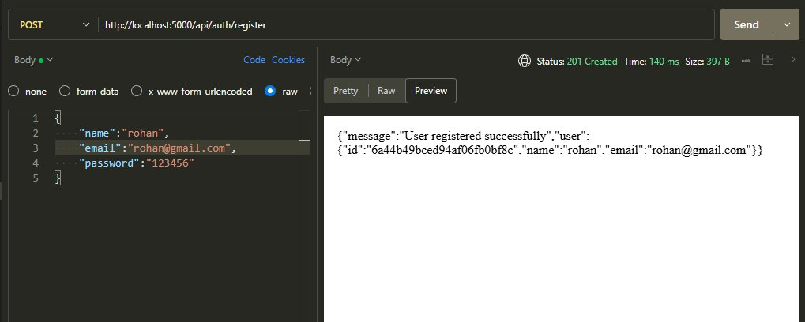
Figure 13.1: POST /api/auth/register returns 201 Created
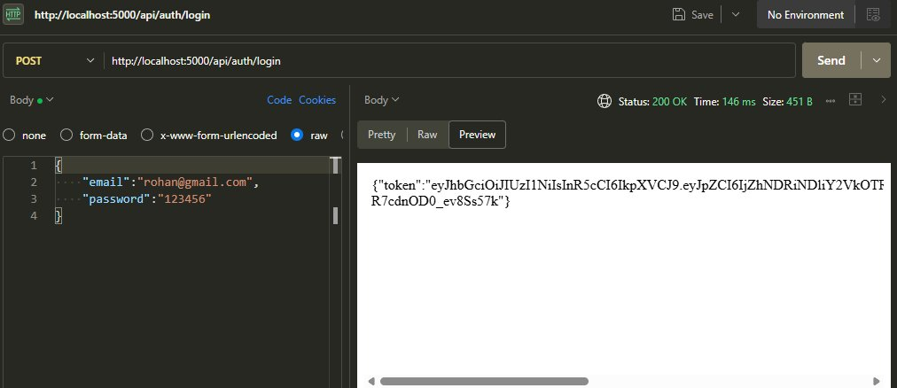
Figure 13.2: POST /api/auth/login returns 200 OK with a JWT

13.5 Evidence: Blog Operations
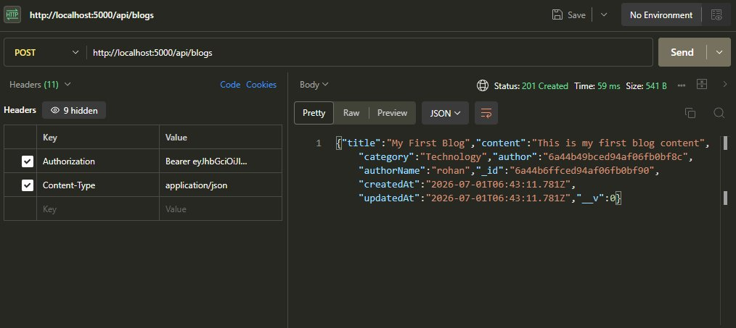
Figure 13.3: POST /api/blogs returns 201 Created with a bearer token
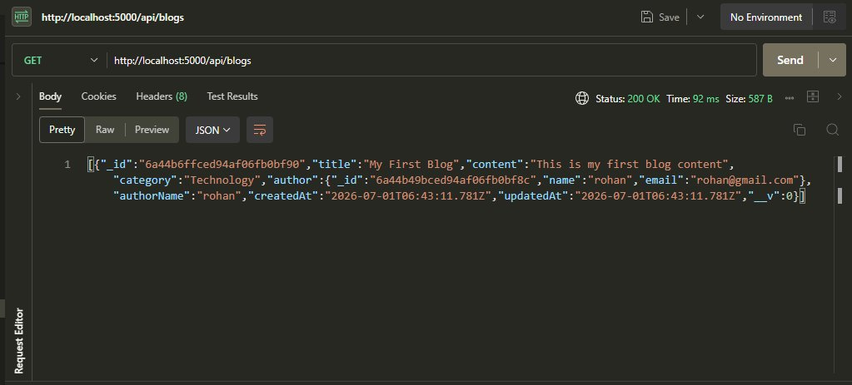
Figure 13.4: GET /api/blogs returns 200 OK with populated author

13.6 Evidence: AI Endpoints
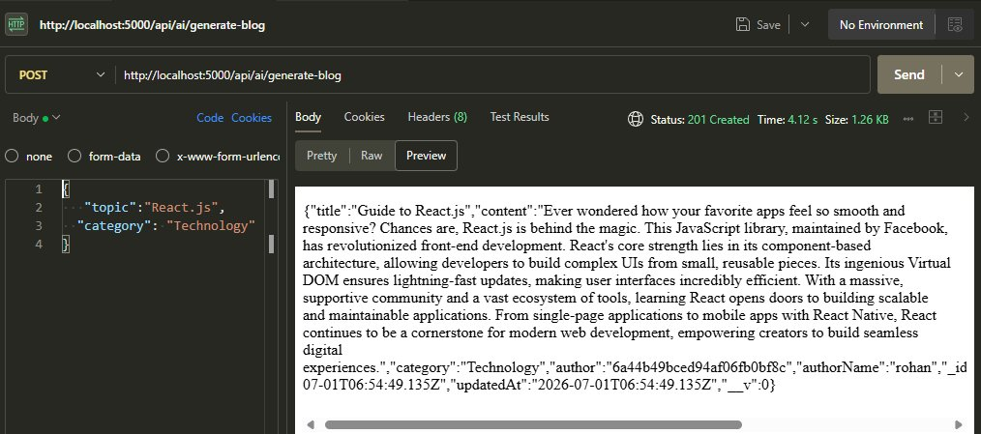
Figure 13.5: POST /api/ai/generate-blog returns 201 Created with generated content
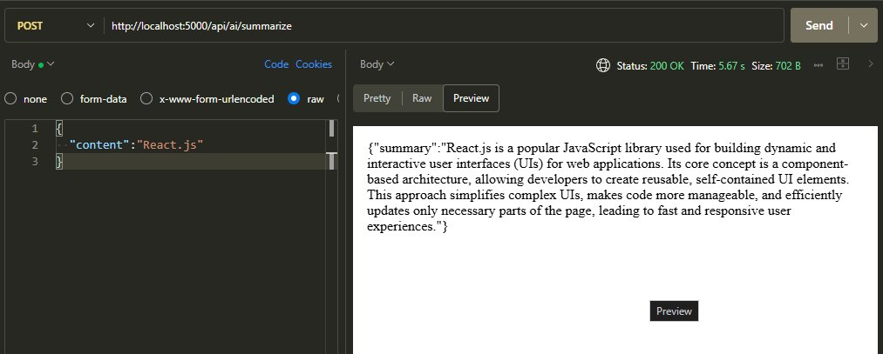
Figure 13.6: POST /api/ai/summarize returns 200 OK with a summary

13.7 Findings from the Recorded Session
- Startup logs confirmed a successful Atlas connection before requests were made.
- The server log lines produced by morgan show the method, path, status and time for every call, which made failures easy to trace.
- The 404 on register was caused by using the wrong HTTP method, not by a server defect; it confirms that unknown method and path combinations are rejected.
- The 503 on AI generation came from the upstream provider. The API handled it without crashing, and a repeat call succeeded.

14. Results and Performance Analysis

14.1 Measured Response Times
Endpoint | Status | Time | Size
POST /api/auth/register | 201 | 140 ms | 397 B
POST /api/auth/login | 200 | 146 ms | 451 B
POST /api/blogs | 201 | 59 ms | 541 B
GET /api/blogs | 200 | 92 ms | 587 B
POST /api/ai/generate-blog | 201 | 4.12 s | 1.26 KB
POST /api/ai/summarize | 200 | 5.67 s | 702 B

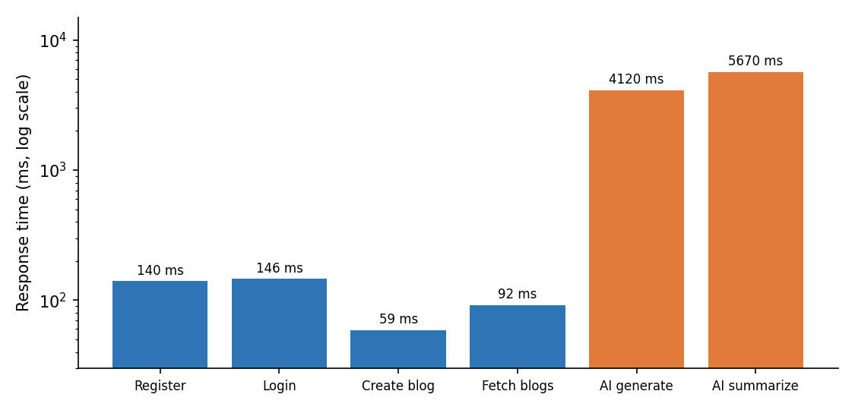
Figure 14.1: Response time per endpoint (log scale)

14.2 Analysis
- Database endpoints are fast. Creating and reading blogs took under 100 ms. Registration and login are slightly slower because password hashing and comparison are deliberately expensive.
- AI endpoints dominate latency. Generation and summarization took four to six seconds, roughly 30 to 100 times longer than database calls. The time is spent waiting for the model, not in Node.js.
- Response sizes are small. Even a generated article is about a kilobyte, so bandwidth is not a concern.

14.3 Objective Achievement
Objective | Result
Secure registration and login | Achieved: hashed passwords and JWT issued.
Blog create and retrieve | Achieved: 201 and 200 responses with author linkage.
AI blog generation | Achieved: content generated and saved automatically.
AI summarization | Achieved: concise summary returned.
Secrets outside code | Achieved: .env plus .gitignore.
Modular structure | Achieved: MVC plus services layer.
Endpoint verification | Achieved: all endpoints exercised and recorded.

14.4 Usability for Front-End Developers
Responses use consistent field names (title, content, category, author, authorName, createdAt), so a front end can bind them directly to components. A Thunder Client collection exported with the project lets new team members replay every request in minutes.

15. Deployment Guide

15.1 Local Run
- Clone or copy the project and run npm install.
- Create .env from the template in Listing 8.1 and fill in real values.
- Run npm run dev for development or npm start for a single run.
- Open http://localhost:5000/ and confirm the message "AI BlogNest API is running".
- Import the Thunder Client collection and run the requests in the order: register, login, create blog, fetch blogs, generate blog, summarize.

15.2 Production Checklist
Area | Action
Hosting | Deploy to a Node-capable platform such as Render, Railway, Azure App Service or a container host.
Environment | Set NODE_ENV=production and provide every variable from Appendix B through the platform's secret store.
Database | Use a dedicated Atlas cluster, restrict network access to the host's IP addresses and enable backups.
Transport | Serve over HTTPS only; restrict CORS to known front-end origins.
Logging | Replace morgan "dev" format with "combined" and forward logs to a central service.
Process management | Use the platform's restart policy or a process manager such as PM2.
Monitoring | Track response times and error rates, with alerts on repeated 5xx from the AI provider.

15.3 Troubleshooting
Symptom | Likely cause | Fix
Process exits with "MONGO_URI is not defined" | .env missing or not loaded | Create .env in the project root and restart
MongoDB connection error | IP not whitelisted or wrong credentials | Update Atlas network access and URI
404 on an endpoint | Wrong HTTP method or path | Check the endpoint table in Section 11
401 on blog creation | Missing or expired token | Log in again and set the Authorization header
503 on AI endpoints | Provider temporarily overloaded | Retry; add back-off (Listing 10.3)
AI errors about key or model | Invalid GEMINI_API_KEY or GEMINI_MODEL | Check both values in .env

16. Limitations and Future Enhancements

16.1 Current Limitations
- Only create and list operations are implemented for blogs; there is no update or delete.
- There is a single user type; role-based permissions are designed but not enforced.
- No pagination, search or filtering on the blog list.
- No rate limiting on login or AI endpoints.
- AI failures are returned to the client without automatic retry.
- No automated test suite; verification was manual.

16.2 Roadmap
Priority | Enhancement | Benefit
High | Update and delete endpoints with ownership checks | Completes the blog CRUD cycle
High | Role-based access control (Reader, Author, Editor, Admin) | Matches the collaboration model in the case study
High | Retry with back-off around Gemini calls | Absorbs transient 503 errors seen in testing
Medium | Rate limiting, helmet, input sanitization | Reduces abuse and injection risk
Medium | Pagination, search and category filters | Scales the list endpoint
Medium | Category and Comment collections with moderation | Implements the full ER diagram
Medium | Post status workflow: draft, pending, scheduled, published | Supports editorial review and scheduling
Low | Likes and engagement analytics | Gives creators performance insight
Low | Additional AI tools: title suggestions, SEO metadata, tone rewrite | Extends the AI layer with the same service pattern
Low | Automated tests (Jest and Supertest) and CI | Prevents regressions
Low | Docker image and cloud deployment pipeline | Repeatable releases

17. Conclusion
AI BlogNest demonstrates how a conventional REST backend and a generative model can work together in a clean, secure and maintainable way. The project delivers a working authentication system, blog storage and retrieval, and two AI features that generate and summarize content. The recorded session shows every implemented endpoint responding correctly against a live MongoDB Atlas database, with database calls completing in under 150 ms and AI calls in a few seconds.
The architecture is intentionally simple to extend. MVC keeps responsibilities separate, the services layer confines vendor-specific code to one file, and environment-based configuration keeps secrets out of source control. The one operational issue observed, a transient 503 from the AI provider, points directly to the next improvement: retry with exponential back-off.
With the planned additions of role-based access, post workflow, moderation and analytics, the platform can grow from a demonstrator into a full AI-assisted content management system that reduces the effort of producing and managing content for creators such as Priya.

References
- Express.js documentation. https://expressjs.com
- Mongoose documentation. https://mongoosejs.com
- MongoDB Atlas documentation. https://www.mongodb.com/docs/atlas
- Google AI for Developers: Gemini API. https://ai.google.dev
- M. Jones, J. Bradley, N. Sakimura. JSON Web Token (JWT), RFC 7519, IETF, 2015.
- OWASP. Top Ten Web Application Security Risks. https://owasp.org/www-project-top-ten
- Node.js documentation. https://nodejs.org/docs

Appendix A: Resource Links
The following resources accompany the demo document.
Resource | Link
Demo videos folder | https://drive.google.com/drive/folders/1npyGtRjLGZtjm6-03dbNGqCpstw_St_u
API testing video | https://drive.google.com/file/d/1mfPIZq0dpU1TAvZk6_Te9StsQXBBDaow/view
Source code folder | https://drive.google.com/drive/folders/1S69VGxkcmkrsPhfJ6CE9af4Nf9WVnLsj

Appendix B: Environment Variables
Variable | Required | Description
PORT | No | HTTP port; defaults to 5000
MONGO_URI | Yes | MongoDB Atlas connection string
JWT_SECRET | Yes | Secret used to sign and verify tokens
GEMINI_API_KEY | Yes | API key for Google Gemini
GEMINI_MODEL | Yes | Name of the Gemini model to call
NODE_ENV | No | development or production

Appendix C: Glossary
Term | Meaning
API | Application Programming Interface; a defined way for programs to talk to each other.
REST | Architectural style using HTTP methods and resource URLs.
JWT | JSON Web Token; a signed token that carries identity claims.
bcrypt | Password-hashing algorithm designed to be slow to brute-force.
ODM | Object-Document Mapper; Mongoose is the ODM for MongoDB.
MVC | Model-View-Controller design pattern.
Middleware | Function that processes a request before it reaches a route handler.
LLM | Large Language Model, such as Gemini.
CORS | Cross-Origin Resource Sharing; browser rule for requests between origins.
Back-off | Waiting progressively longer between retries.

